

**COMSATS University, Islamabad Pakistan**

**Project Name**

***By***

**Student Name 1 CIIT/SP09-BCS-xxx/ISB**

**Student Name 2 CIIT/SP09-BCS-xxx/ISB**

***Supervisor*Supervisor Name**

***Bachelor of Science in Computer Science / Software Engineering (20xx-20xx)***

**The candidate confirms that the work submitted is their own and appropriate  
 credit has been given where reference has been made to the work of others**.



**COMSATS University, Islamabad Pakistan**

**Project Name**

**A project presented to**

**COMSATS University, Islamabad**

**In partial fulfillment**

**of the requirement for the degree of**

***Bachelors of Science in Computer Science / Software Engineering (20xx-20xx)***

**By**

**Student Name 1 CIIT/SP09-BCS-xxx/ISB**

**Student Name 2 CIIT/SP09-BCS-xxx/ISB**

**DECLARATION**

We hereby declare that this software, neither whole nor as a part has been copied out from any source. It is further declared that we have developed this software and accompanied report entirely on the basis of our personal efforts. If any part of this project is proved to be copied out from any source or found to be reproduction of some other, we will stand by the consequences. No Portion of the work presented has been submitted of any application for any other degree or qualification of this or any other university or institute of learning.

Student Name 1 Student Name 2

--------------------------- ---------------------------

**CERTIFICATE OF APPROVAL**

It is to certify that the final year project of BS (CS) Dukan was developed by   
**MUZAMAL RIAZ (CIIT/SP19-BSE-092)** and **UMAIR KHALID (CIIT/SP19-BCS-004)** under the supervision of SARA ALI and co supervisor “CO-SUPERVISOR NAME” and that in (their/his/her) opinion; it is fully adequate, in scope and quality for the degree of Bachelors of Science in Computer Sciences / Software Engineering.

---------------------------------------

**Supervisor**

---------------------------------------

**External Examiner**

---------------------------------------

**Head of Department**

**(Department of Computer Science)**

**Executive Summary**

In public places, there is often a need for monitoring people and different activities going on, which can be referred later for many reasons including security. Appointing humans for this task involves many problems such as increased employee hiring, accuracy problem, trust, no proof for later use, and also the fact that a human can remember things till a certain time limit. Talking about the current security system, they use still cameras with a continuous recording facility irrespective of the fact that any event may happen or not. Moreover they are usually pointing at a specific user defined locations so more than one camera are required to cover the entire region.

To prevent all these problems from prevailing, the CSCS is developed. It is a surveillance system, which provides solution to many of these problems. It is a stand-alone application which doesn’t require any computer to operate. It monitors different situations using a camera which is able to rotate intelligently based on sensor messages and captures the scene in the form of video or photos later reference as well.

**C**ustomizable **S**urveillance **C**ontrol **S**ystem **(CSCS)** is a surveillance system that can be assigned a sensor type as in our case a heat sensor is used, it works accordingly, rotates the camera upon event detection and perform user defined actions like capturing video and stores them, for the future use.

It is an embedded system consisting of Linux fox kit with embedded a running server application also a camera, USB storage device and a sensor node base station is attached with fox kit. LAN communication is used by user to download the videos and to operate the system manually.

**Acknowledgement**

All praise is to Almighty Allah who bestowed upon us a minute portion of His boundless knowledge by virtue of which we were able to accomplish this challenging task.

We are greatly indebted to our project supervisor “_______” and our Co-Supervisor “_____”. Without their personal supervision, advice and valuable guidance, completion of this project would have been doubtful. We are grateful to them for their encouragement and continual help during this work.

And we are also thankful to our parents and family who have been a constant source of encouragement for us and brought us with the values of honesty & hard work.

Student Name 1 Student Name 2

--------------------------- ---------------------------

**Abbreviations**

|  |  |
| --- | --- |
| **SRS** | Software Require Specification |
| **PC** | Personal Computer |
|  |  |
|  |  |
|  |  |

**Table of Contents**

1 Introduction 1

1.1 Vision Statement 1

1.2 Related System Analysis/Literature Review 1

1.3 Project Deliverables 2

1.4 System Limitations/Constraints 2

1.5 Tools and Technologies 2

1.6 Relevance to Course Modules 2

2 Problem Definition 3

2.1 Problem Statement 3

2.2 Problem Solution 3

2.3 Objectives of the Proposed System 3

2.4 Scope 4

2.5 Modules 4

2.5.1 Module 1: Module Name 4

3 Requirement Analysis 5

3.1 User classes and characteristics 5

3.2 Requirement Identifying Technique 5

3.3 Functional Requirements 5

3.3.1 Functional Requirement X 5

3.4 Non-Functional Requirements 6

3.4.1 Reliability 6

3.4.2 Usability 7

3.4.3 Performance 7

3.4.4 Security 7

3.5 External Interface Requirements 7

3.5.1 User Interfaces Requirements 7

3.5.2 Software interfaces 8

3.5.3 Hardware interfaces 8

3.5.4 Communications interfaces 8

4 Design and Architecture 9

4.1 Architectural Design 9

4.2 Design Models 9

4.3 Data Design 10

4.3.1 Data Dictionary 10

5 Implementation 11

5.1 Algorithm 11

5.2 External APIs/SDKs 13

5.3 User Interface 13

5.3.1 Login Screen 5.3.2 Home Screen 14

5.3.3 Assignee Dashboard 15

5.3.4 New Complaint 15

5.4 Deployment 16

6 Testing and Evaluation 17

6.1 Unit Testing 17

6.2 Functional Testing 17

6.3 Business Rules Testing 18

6.4 Integration Testing 18

7 Conclusion and Future Work 19

7.1 Conclusion 19

7.2 Future Work 19

8. References 20

**List of Figures**

Figure 1Home Screen 23

Figure 2 Login Screen 23

Figure 3 Assignee Dashboard 24

Figure 4 New Complaint 24

Figure A-5: Context diagram of the Cafeteria Ordering System. 30

Figure A-6: Use Case Diagram of an Appointment System 32

Figure B-7 Box-and-Line Diagram for an Online Shopping Business 40

Figure B-8 Component-based Layered Architecture 41

# Introduction

This chapter provides the overview of the project. The first paragraph of every chapter should provide the chapter summary.

## Vision Statement

Write a concise vision statement that summarizes the long-term purpose, intent and significance of the product. The vision statement should reflect a balanced view that will satisfy the expectations of diverse stakeholders. It can be somewhat idealistic but should be grounded in the realities of existing or anticipated markets. The following keyword template works well for crafting a product vision statement:

1. ***For*** [target customer]
2. ***Who*** [statement of the need or opportunity]
3. ***The*** [product name]
4. ***Is*** [product category]
5. ***That*** [major capabilities, key benefit, compelling reason to buy or use]
6. ***Unlike*** [primary competitive alternative, current system, current business process]
7. ***Our product*** [statement of primary differentiation and advantages of new product]

Here’s a sample vision statement for the Chemical Tracking System, with the keywords in boldface:

***For*** *employees* ***who*** *want to order meals from the company cafeteria or from local restaurants online,* ***the*** *Cafeteria Ordering System* ***is*** *an Internet-based and smartphone-enabled application* ***that*** *will accept individual or group meal orders, process payments, and trigger delivery of the prepared meals to a designated location on the Process Impact campus.* ***Unlike*** *the current telephone and manual ordering processes, employees who use* ***our product*** *(the Cafeteria Ordering System) will not have to go to the cafeteria to get their meals, which will save them time and will increase the food choices available to them.*

## Related System Analysis/Literature Review

**Write** about the existing/similar systems related to your proposed project.

Don’t use more than 4 sentences for explaining a single system/application.

Briefly provide an analysis of the related system which may help you to specify the contribution of the proposed project.

Table 1 Related System Analysis with proposed project solution

|  |  |  |
| --- | --- | --- |
| **Application Name** | **Weakness** | **Proposed Project Solution** |
| The name of related application(s). | Weaknesses may include limited features, low quality functionality and processes. | The way the proposed project mitigates the weaknesses. |
|  |  |  |

## Project Deliverables

List down the project deliverables.

## System Limitations/Constraints

Write down the limitations and constraints of the proposed project.

**Example:**

*LI-1: Some food items that are available from the cafeteria will not be suitable for delivery, so the delivery menus available to patrons of the COS must be a subset of the full cafeteria menus.*

*LI-2: The COS shall be used only for the cafeteria at the Process Impact campus in Clackamas, Oregon.*

## Tools and Technologies

Mention all the hardware/software tools and technologies with version number which will be used in implementation of the project. Write about the APIs, language(s), SDK(s) etc. which you will use for implementation.

Example:

Table 2 Tools and Technologies for Proposed Project

|  |  |  |  |
| --- | --- | --- | --- |
| **Tools**  **And**  **Technologies** | **Tools** | **Version** | **Rationale** |
| MS Visual Studio | 2015 | IDE |
| MS SQL Server | 2015 | DBMS |
| Adobe Photoshop | CSC 6 | Design Work |
| **Technology** | **Version** | **Rationale** |
| React JS | 17 | Front-end Development |
| ASP.net Core | 3 | Back-end Development |
| C# | 8 | Back-end Development |

## Relevance to Course Modules

A brief explanation of how your project is related to various courses studied during BCS.

# Problem Definition

This chapter discusses the precise problem to be solved. It should extend to include the outcome.



## Problem Statement

Provide a problem statement in a concise paragraph describing

**Why** are you developing this software system?

**What** problem your software system is going to solve?

[Usually in 10-16 sentences]

**Example:**

*Employees at the company Process Impact presently spend an average of 65 minutes per day going to the cafeteria to select, purchase, and eat lunch. About 20 minutes of this time is spent walking to and from the cafeteria, selecting their meals, and paying by cash or credit card. When employees go out for lunch, they spend an average of 90 minutes off-site. Some employees phone the cafeteria in advance to order a meal to be ready for them to pick up. Employees don‘t always pet the selections they want because the cafeteria runs out of certain items. The cafeteria wastes a significant quantity of food that is not purchased and must be thrown away. These same issues apply to breakfast and supper, although far fewer employees use the cafeteria for those meals than for lunch.*

## Problem Solution

Describe the application of software being specified including objectives and goals keeping in view the problem statement listed in Section 2.

[Provide list of objectives]

[Usually in 14-16 sentences]

**Example:**

*Many employees have requested a system that would permit a cafeteria user to order meals (defined as a set of one or more food items selected from the cafeteria menu) online, to be picked up at the cafeteria or delivered to a company location at a specified time and date. Such a system would save employees time, and it would increase their chance of getting the items they prefer. Knowing what food items customers want in advance would reduce waste in the cafeteria and would improve the efficiency of cafeteria staff. The future ability for employees to order meals for delivery from local restaurants would make a wide range of choices available to employees and provide the possibility of cost savings through volume discount agreements with the restaurants.*

## Objectives of the Proposed System

**Example:**

*BO-1: Reduce the cost of cafeteria food wastage by 40%.*

*BO-2: Reduce cafeteria operating costs by 15%.*

*BO-3: Increase average effective work time by 15 minutes per cafeteria-using employee per day.*

## Scope

Write down the scope of your project in a paragraph. Briefly define the main functionalities of the proposed project. Scope defines the **boundaries and range** of the proposed solution, that what would be the part of your project. Write down in logical flow with consistency.

(Usually in 14-18 sentences)

## Modules

Write down the modules of the proposed project.

Each module should **highlight features**, using bulleted/numbered notation.

When developing both a mobile app and a web app, group the modules according to the system types, such as, Client Web App, Client Mobile App, Admin Web App etc.

### Module 1: Module Name

[List of features]

**Example:**

Module 1: Order Meal

*FE-1: Order and pay for meals from the cafeteria menu to be picked up or delivered.*

*FE-2: Order and pay for meals from local restaurants to be delivered.*

Module 2: Menu Operations

*FE-1: Create, view, modify, and cancel meal subscriptions for standing or recurring meal orders, or for daily special meals.*

*FE-2: Create, view, modify, delete, and archive cafeteria menus.*

*FE-3: View ingredient lists and nutritional information for cafeteria menu items.*

# Requirement Analysis

Provide an introduction to the chapter in a few lines. Write details in each of the sections provided ahead.



## User classes and characteristics

Identify the various user classes that you anticipate will use this product, and describe their pertinent characteristics. See Appendix A for an example of how to present user classes and characteristics.

## Requirement Identifying Technique

This section describes the requirements identifying technique(s) which further help to derive functional requirements specification. The selection of the technique(s) will depend on the type of project. For instance,

* **Use case (use case diagram + detail use case)** is an effective technique for interactive end-user applications.
* **Event- response table** is for real-time system in which most of the functionalities are performed at backend.
* **Storyboarding** for graphically intensive applications.

Examples of above techniques are given in Appendix A

## Functional Requirements

This section describes the functional requirements of the system expressed in the natural language style. This section is typically organized by feature as a system feature name and specific functional requirements associated with this feature. It is just one possible way to arrange them. Other organizational options include arranging functional requirements by use case, process flow, mode of operation, user class, stimulus, and response depend on what kind of technique has been used to understand functional requirements. Hierarchical combinations of these elements are also possible, such as use cases within user classes. For further detail see Chapter 10 “Documenting the requirements”. Let consider the feature scheme as an example.

### Functional Requirement X

Itemize the specific functional requirements associated with each feature. These are the software capabilities that must be implemented for the user to carry out the feature’s services or to perform a use case. Describe how the product should respond to anticipated error conditions and to invalid inputs and actions. Uniquely label each functional requirement, as described earlier. You can create multiple attributes for each functional requirement, such as rationale, source, dependencies, etc. The following template is required to write functional requirements. For further detail see Chapter 11” Writing excellent requirements”.

Table 3 Description of FR-1

|  |  |
| --- | --- |
| **Identifier** | FR-1 |
| **Title** | Title of requirement |
| **Requirement** | Description of requirement which may be written either from the user or system perspective e.g.  If written in a **user perspective**  The [user class or actor name] shall be able to [do something] [to some object] [qualifying conditions, response time, or quality statement].  If written in a **system perspective**  [optional precondition] [optional trigger event] the system shall [expected system response] |
| **Source** | Where this requirement comes from (who originate it) |
| **Rationale** | The motivation behind the requirement |
| **Business Rule (if required)** | Any restriction, policy, the rule that the particular requirement must be fulfilled through its functional behavior |
| **Dependencies** | Requirements ID that is dependent on this requirement |
| **Priority** | High/Medium/Low |

## Non-Functional Requirements

This section specifies nonfunctional requirements other than constraints, which are recorded in section 2.3, and external interface requirements, which will appear in section 7. These quality requirements should be specific, quantitative, and verifiable. Chapter 14 “beyond functionality” presents more information about these quality attribute requirements and many examples. The following are some examples of documenting guidelines.

### Reliability

Requirements about how often the software fails. The measurement is often expressed in MTBF (mean time between failures). The definition of a failure must be clear. Also, don't confuse reliability with availability which is quite a different kind of requirement.  Be sure to specify the consequences of software failure, how to protect from failure, a strategy for error detection, and a strategy for correction.

### Usability

Usability requirements deal with ease of learning, ease of use, error avoidance and recovery, the efficiency of interactions, and accessibility. The usability requirements specified here will help the user interface designer create the optimum user experience.

Example:

*USE-1: The COS shall allow a user to retrieve the previous meal ordered with a single interaction.*

### Performance

State specific performance requirements for various system operations. If different functional requirements or features have different performance requirements, it’s appropriate to specify those performance goals right with the corresponding functional requirements, rather than collecting them in this section.

Example:

*PER-1: 95% of webpages generated by the COS shall download completely within 4 seconds from the time the user requests the page over a 20 Mbps or faster Internet connection.*

### Security

One or more requirements about protection of your system and its data. The measurement can be expressed in a variety of ways (effort, skill level, and time) to break into the system.  Do not discuss solutions (e.g. passwords) in a requirements document.

## External Interface Requirements

This section provides information to ensure that the system will communicate properly with users and with external hardware or software elements. A complex system with multiple subcomponents should create a separate interface specification or system architecture specification. The interface documentation could incorporate material from other documents by reference. For instance, it could point to a hardware device manual that lists the error codes that the device could send to the software.

### User Interfaces Requirements

Describe the logical characteristics of each user interface that the system needs. Some possible items to include are

* References to GUI standards or product family style guides that are to be followed.
* Standards for fonts, icons, button labels, images, color schemes, field tabbing sequences, commonly used controls, and the like.
* Screen layout or resolution constraints.
* Standard buttons, functions, or navigation links that will appear on every screen, such as a help button.
* Shortcut keys.
* Message display conventions.
* Layout standards to facilitate software localization.
* Accommodations for visually impaired users.

Document the user interface design details, such as specific dialog box layouts, in a separate user interface specification, not in the SRS. Including screen mock-ups in the SRS to communicate another view of the requirements is helpful but make it clear that the mock-ups are not the committed screen designs. If the SRS is specifying an enhancement to an existing system, it sometimes makes sense to include screen displays exactly as they are to be implemented. The developers are already constrained by the current reality of the existing system, so it's possible to know up front just what the modified, and perhaps the new, screens should look like.

### Software interfaces

Describe the connections between this product and other software components (identified by name and version), including other applications, databases, operating systems, tools, libraries, websites, and integrated commercial components (If any).

Example:

SI-1: Cafeteria Inventory System

*SI-1.1: The COS shall transmit the quantities of food items ordered to the Cafeteria Inventory System through a programmatic interface*.

### Hardware interfaces

Describe the characteristics of each interface between the software components and hardware components, if any, of the system. This description might include the supported device types, the data and control interactions between the software and the hardware, and the communication protocols to be used. For more about specifying requirements for systems containing hardware, see Chapter 26, “Embedded and other real-time systems projects.”

### Communications interfaces

State the requirements for any communication functions the product will use, including email, web browser, network protocols, and electronic forms.

Example:

*CI-1: The COS shall send an email or text message (based on user account settings) to the Patron to confirm acceptance of an order, price, and delivery instructions.*

# Design and Architecture

The following parts of Software Design Description (SDD) report should be included in this chapter.



## Architectural Design

Develop a modular program structure and explain the relationships between the modules to achieve the complete functionality of the system. This is a high-level overview of how the system’s modules collaborate with each other in order to achieve the desired functionality.

Don’t go into too much detail about the individual subsystems. The main purpose is to gain a general understanding of how and why the system was decomposed, and how the individual parts work together.

Provide a diagram showing the major subsystems and their connections.

* In initial design stage create Box and Line Diagram for simpler representation of the systems
* After finalizing architecture style/pattern diagram (MVC, Client-Server, Layered, Multi-tiered) create a detailed mapping modules/components to each part of the architecture

To view example of box and line diagram and architecture styles, see Appendix B.

## Design Models

Create design models as are applicable to your system. Provide detailed descriptions with each of the models that you add. Also ensure visibility of all diagrams.

***Design Models for Object Oriented Development Approach***

The applicable models for the project using object oriented development approach may include:

* Activity Diagram
* Class Diagram
* Sequence Diagram
* State Transition Diagram (for the projects which include event handling and backend processes)

***Design Models for Procedural Approach***

The applicable models for the project using procedural approach may include:

* Activity Diagram
* Data Flow Diagram (data flow diagram should be extended to 2-3 levels. It should clearly list all processes, their sources/sinks and data stores.)
* State Transition Diagram (for the projects which include event handling and backend processes)

To view examples of all above models, see Appendix C

## Data Design

Explain how the information domain of your system is transformed into data structures. Describe how the major data or system entities are stored, processed, and organized.

List any databases or data storage items.

### Data Dictionary

Alphabetically list the system entities or major data along with their types and descriptions. If you provided a functional description, list all the functions and function parameters. If you provided an OO description, list the objects and its attributes, methods and method parameters.

# Implementation

This chapter will discuss implementation details of the project. You will not put your source code here, however, are required to write the core modules functionalities in pseudocode form (Following sections are required in this chapter).

Note: You are required to follow proper coding standard to write your source code. For guidelines, **General Coding Standards & Guidelines** are provided in Appendix D.



## Algorithm

Mention the algorithm(s) used in your project to get the work done with regards to major modules. Provide a pseudocode explanation regarding the functioning of the core features. Be sure to use the correct syntax and semantics for algorithm representations. Following are few examples of algorithms/pseudocode:

Table 4 Example of Algorithm

|  |  |  |
| --- | --- | --- |
| **Algorithm 1 MHCF co-authorsBasedClustering** | | |
| **Input:** n groups Gn where each group has set of papers (pr) | | |
| **Output:** Set of system generated clusters/groups Gn | | |
| 1: merge ← true  2: Flag ← false  3: **While**(merge==’true’) **do:**  4: merge ← false  5: **for** i in range (0: len(G)-1):  6: **for** j in range (i+1: len(G)):  7: **if** (similarCoauthors(GiLco-authors, GjLco-authors) == true) **then**  8: Flag ← true  9: **Else** (checkNameFragments(GiLco-authors, GjLco-authors) == true) **then**  10: Flag ← true  11: **if** (Flag == true) **then**  12: Gi ← Gi U Gj  13: G ← G.pop(j)  14: merge ← true  15: **end if**  16: **end for**  17: **end for**  18: **end while** | | |
| **Algorithm 1.1 checkNameFragments** | | |
| **Input:** two lists GiLco-authors, GjLco-authors where each list has co-authors | | |
| **Output:** Boolean value | | |
| 1: Flag ← false  2: Count ← 0  3: **foreach co-author1 in GiLco-authors:**  4: coauthor1Fragments ← co-author1.split(‘ ’)  5: **foreach co-author2 in GjLco-authors:**  6: coauthor2Fragments ← co-author2.split(‘ ’) //split author name into name fragments  7: **if** (len(coauthor1Fragments) == 3 **and** len(coauthor2Fragments) == 3) **then** //both authors have three name fragments  8: **if** (len(coauthor1Fragments[0]) ≥ 3 and len(coauthor1Fragments[0]) ≥ 3) **then**  9: //both authors first name have more than three characters  10: **if**(coauthor1Fragments[0] == coauthor2Fragments[0]) and (coauthor1Fragments[2] == coauthor1Fragments[2])) **then**  11: //both authors have same full first and last name  12: **if** ((coauthor1Fragments[1] == coauthor2Fragments[1]) or (coauthor1Fragments[1][0] == coauthor2Fragments[1][0])) **then**  13: //both authors have same middle full name or same first character of middle name  14: Count++  15: **end if**  16: **elseif** ((coauthor1Fragments[0][0] == coauthor2Fragments[0][0] and coauthor1Fragments[0][1] == coauthor2Fragments[0][1] and coauthor1Fragments[0][2] == coauthor2Fragments[0][2]) and (coauthor1Fragments[2] == coauthor1Fragments[2])) **then**  17: //both authors have same first three characters of first name and full last name  18: **if** ((coauthor1Fragments[1] == coauthor2Fragments[1]) or (coauthor1Fragments[1][0] == coauthor2Fragments[1][0])) **then**  19: //both authors have same middle full name or same first character of middle name  20: Count++  21: **endif**  22: **end elseif**  23: **elseif** (len(coauthor1Fragments) > 3 and len(coauthor2Fragments) > 3)) **then** //both have more than three name fragments  24: **if** ((coauthor1Fragments[0][0] == coauthor2Fragments[0][0] and coauthor1Fragments[0][1] == coauthor2Fragments[0][1] and coauthor1Fragments[0][2] == coauthor2Fragments[0][2]) and ((coauthor1Fragments[len(coauthor1Fragments)-1] == coauthor2Fragments[len(coauthor2Fragments)-1]) or (coauthor1Fragments[len(coauthor1Fragments)-1][0] == coauthor2Fragments[len(coauthor2Fragments)-1][0]))) **then**  //both have same first three characters of first name and either full last name or first character of last name  25: **if** (coauthor1Fragments[1][0] == coauthor2Fragments[1][0]) **then** //both have same first character of their second name  26: count++  27: **end if**  28: **end if**  29: **end elseif**  30: **end foreach**  31: **end foreach**  32: **if** (count ≥ 1) **then //**number ofsimilar co-authors excluding author in question  33: Flag ← true  34: **endif**  35: **return** Flag | | |
| **Algorithm 2 MHCF titleBasedClustering** | | **Algorithm 2.1 similarTitles** |
| **Input:** n groups Gn where each group has set of papers pr | | **Input: string literals of paper title, threshold_value** |
| **Output:** Set of system generated clusters/groups **Gn** | | **Output: Boolean value** |
| 1: merge ← true, threshold-title ← threshold ← 0.85  2: **While** (merge ==’true’) **do:**  3: merge ← false  4: **for** i in range (0: len(G)-1):  5: **for** j in range (i+1: len(G)):  6: coathr-count = check-coauthors(Gi , Gj)  7: if coathr-count ≥ 1 **then**  8: threshold-title ← threshold – 0.35  9: **if** similarTitles(Gi_title, Gj_title, threshold-title) **then**  10: Gi ← Gi U Gj  11: G ← G.pop(j)  12: merge ← true  13: **end if**  14: **end for**  15: **end for**  16: **end while** | | 7.1: vectori, vectorj ← Research2Vec (titlei, titlej)  7.2: score = 1 – spatial.distance.cosine(vectori, vectorj)  7.3: **if** score ≥ threshold:  7.4: return true  7.5: **else**  7.6: return false  7.7: **end if** |
| **Algorithm 2.2 check-coauthors** | | |
| **Input:** Two groups co-authors list Gi and Gj  **Output:** Count of common co-authors (Number Value)  6.1: common = 0  6.2: if **set** (Gi) & **set** (Gj) **then** //if there exists a common co-author.  6.3: common ← **set** (Gi) & **set** (Gj)  6.4: return len(common) | | |
| **Algorithm 3 MHCF author_affiliationBasedClustering** | **Algorithm 3.1 cosinesimilarity** | |
| **Input:** n groups Gn where each group has set of papers pr | **Input: List of affiliations/emails within the G, threshold** | |
| **Output:** Set of system generated clusters/groups Gn | **Output: Boolean value** | |
| 1: merge ← true  2: **While**(merge==’true’) **do:**  3: merge ← false  4: **for** i in range (0: len(G)-1):  5: **for** j in range (i+1: len(G)):  6: **if** cosinesimilarity (GiLaffiliation, GjLaffiliation) **then**  7: Gi ← Gi U Gj  8: G ← G.pop(j)  9: merge ← true  10: **end if**  11: **end for**  12: **end for**  13: **end while** | 6.1: **for** m in range (0: len(GiLaff) - 1):  6.2 vectori ← cosineSim (GiLaff[m])  6.3: **for** k in range (m+1: len(GjLaff)):  6.4: vectorj ← cosineSim (GjLaff[k])  6.5: score = 1 – spatial.distance.cosine(vectori, vectorj)  6.6: **if** score ≥ threshold:  6.7: return true  6.8: **end if**  6.9: **end for**  6.10: **end for**  6.11: return false | |

## External APIs/SDKs

Describe the third-party APIs/SDKs used in the project implementation in the following table. Few examples of APIs are provided in the table.

Table 5 Details of APIs used in the project

|  |  |  |  |
| --- | --- | --- | --- |
| **Name of API and version** | **Description of API** | **Purpose of usage** | **List down the API endpoint/function/class in which it is used** |
| Stripe (version 2020-08-27) | Credit Card payment integration | Sandbox used for the orders payment | stripe.paymentMethods.create |
| Cloudinary | Image and Video management solution | Uploading Product Images on Cloudinary server | https://api.cloudinary.com/v1_1/demo/image/upload |

## User Interface

Details about user interface with descriptions. Provide the User Interface for each sub-system (such as Mobile App, Web App, Client App, Admin App). Provide description of each User Interface explaining the details.

When inserting User Interfaces, use appropriate size of the image, for example, for mobile app, 2-4 screens can be placed on a single page.

Following are few examples of User Interfaces:

### Login Screen 5.3.2 Home Screen

Login screen of our mobile app where user Home screen where total, delayed and

have to choose its role and its company. Other complaints are shown.

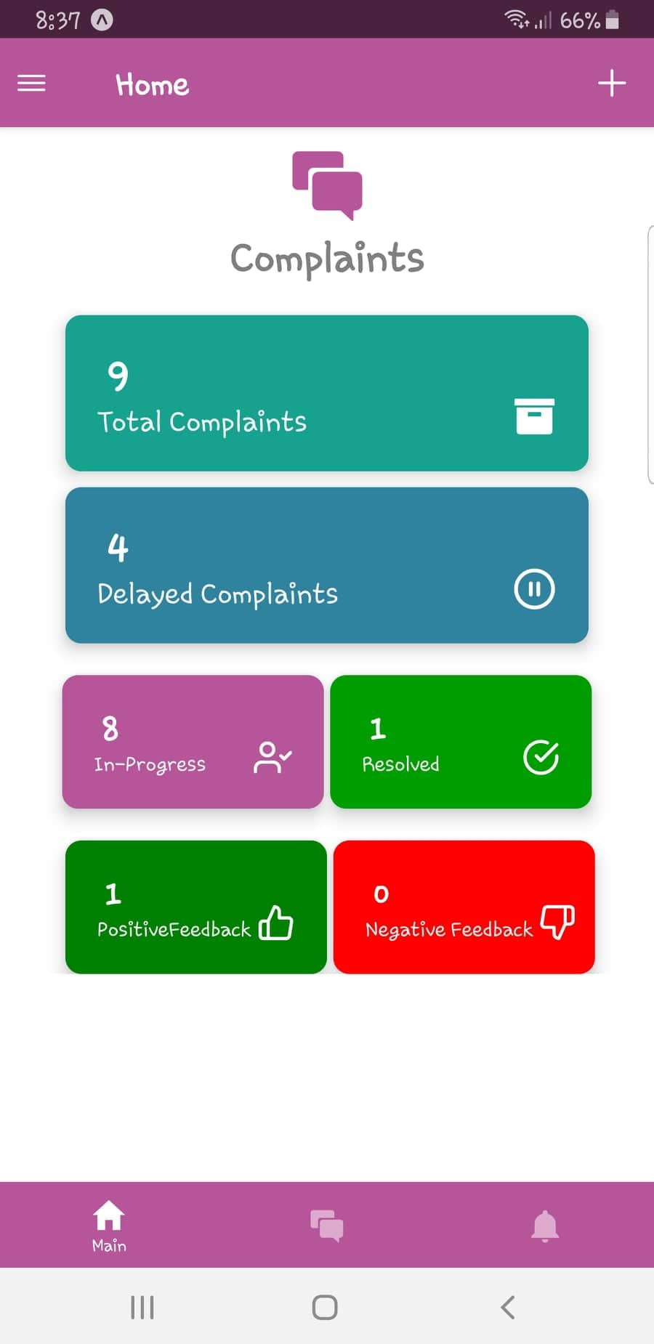

Figure 1Home Screen

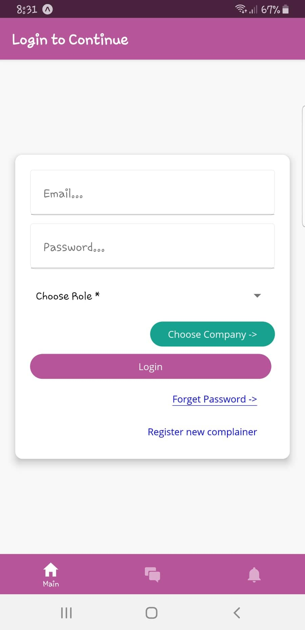

Figure 2 Login Screen

### Assignee Dashboard

Complain Assignee can view the graphs of month-wise complains, Resolved complains, summary and a list of submitted complains.

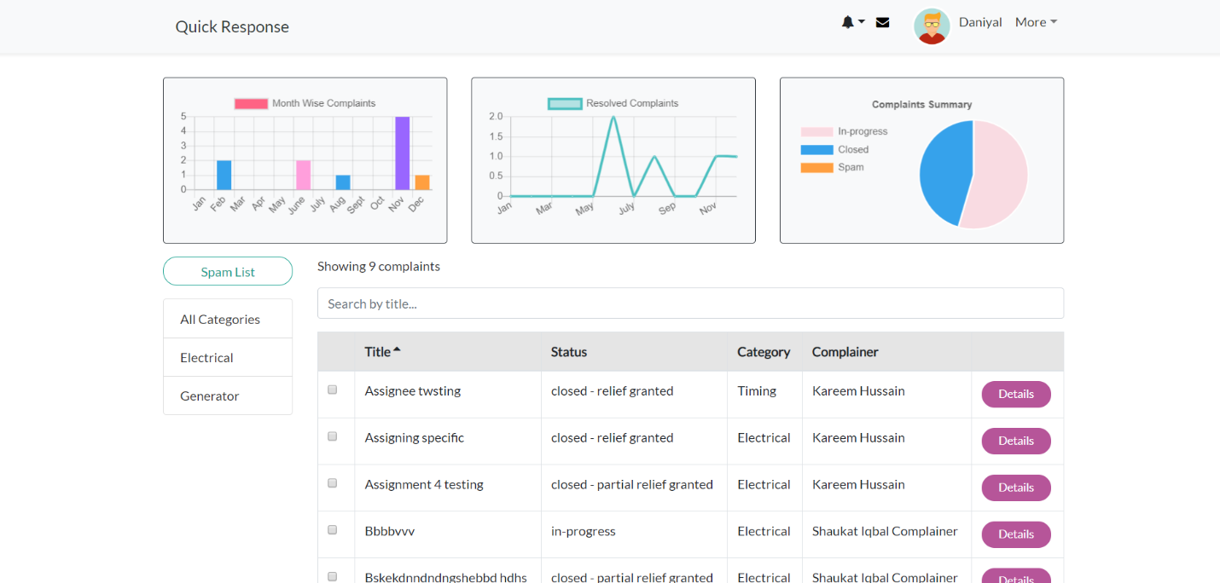

Figure 3 Assignee Dashboard

### New Complaint

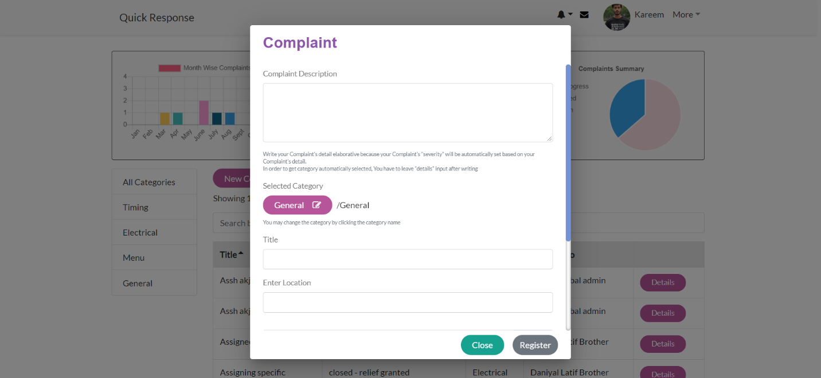Complain Assignee and Complainer can create a new complain by providing Description, Category, Title, Location etc.

Figure 4 New Complaint

## Deployment

Specify the deployment environments used for hosting and live testing of all the sub-systems of the project. Provide the details of hosting/cloud service used, set of available software and their versions used etc.

# Testing and Evaluation



Once the system has been successfully developed, testing has to be performed to ensure that the system working as intended. This is also to check that the system meets the requirements stated earlier. Besides that, system testing will help in finding the errors that may be hidden from the user. The testing must be completed before it is deployed for use.

There are few types of testing which includes the unit testing, functional testing and integration testing.

You are *required* to perform each of these in-depth to ensure system quality.

## Unit Testing

It’s a level of software testing where individual units of a software/component are tested. The purpose is to validate that each unit of the software performs as designed.

**Unit Testing 1:** Login as Patient with valid and invalid credentials

**Testing Objective:** To ensure the login form is working correctly with valid and invalid credentials/inputs.

|  |  |  |  |  |
| --- | --- | --- | --- | --- |
| **No.** | **Test case/Test script** | **Attribute and value** | **Expected result** | **Result** |
| 1 | Check the email field of login to validate that it takes proper email | Email: [abc@gmail.com](mailto:abc@gmail.com) | Validates email address and moves cursor to next textbox | Pass |
| 2 | Check the email field of login to validate that it displays error message. | Email: [abc.gmail.com](mailto:abc@gmail.com) | Highlights field and displays error message | Pass |

## Functional Testing

The functional testing will take place after the unit testing. In this functional testing, the functionality of each of the module is tested. This is to ensure that the system produced meets the specifications and requirements.

**Functional Testing 1:** Login with different roles (Management, Patient, Doctor)

**Objective**: To ensure that the correct page with the correct navigation bar is loaded.

|  |  |  |  |  |  |
| --- | --- | --- | --- | --- | --- |
| **No.** | **Test case/Test script** | **Attribute and value** | **Expected result** | **Actual result** | **Result** |
| 1. | Login as a ‘Management’ member. | Username: (correct username M003)  Password:  (correct password 1234) | Main page for the Management is loaded with the Management navigation bar. | Logged in and redirected to management main page. | Pass |
| 2. | Login as a ‘Doctor’ member. | Username: D003  Password:  1234 | Main page for the Doctor is loaded with the doctor navigation bar. | Login failed – invalid credentials error | Fail |

## Business Rules Testing

Decision table based testing technique is used to test business rules. The business rules were defined in FRs and Use Cases

Decision based testing uses a systematic approach where input and outputs are provided in tabular form. It is a precise and compact way to model complicated logic. The table contains conditions and actions are used for test cases where conditions as inputs and actions as outputs.

Detailed example is as given in Appendix E.

## Integration Testing

Integration tests assess whether a set of classes that must work together do so without error. They

ensure that the interfaces and linkages between different parts of the system work properly. At this point, the classes have passed their individual unit tests, so the focus now is on the flow of control among the classes and on the data exchanged among them. Integration testing follows the same general procedures as unit testing: The tester develops a test plan that has a series of tests, which, in turn, have a test. Integration testing is often done by a set of programmers and/or systems analysts.

**Integration Testing 1:** Scheduling Patient Appointment

**Testing Objective:** To ensure the scheduling is being done correctly and *the* ***interface*** *between* module ‘Patient/Doctor Management’ and module ‘Appointment/Scheduling’ *is running correctly*.

|  |  |  |  |  |  |
| --- | --- | --- | --- | --- | --- |
| **No.** | **Test case/Test script** | **Attribute and value** | **Expected result** | **Actual result** | **Result** |
| 1. | Make Appointment | Doctor schedule, patient preferred date and time | Successfully create doctor-patient appointment showing date and time of appointment. | Appointment created successfully | Pass |
| 2. | Change Appointment booking | Select Date and time | Final date and time of appointment will be shown. | Appointment time changed successfully | Pass |

# Conclusion and Future Work

This chapter concludes the project and highlights future work.



## Conclusion

## Future Work

# References

List any documents or other resources to which this SRS refers, if any. These might include user interface style guides, standards, system requirements specifications, interface specifications, or the SRS for a related product. The following are a few examples of different resources.

**Book**

Author(s). Book title. Location: Publishing company, year, pp.

Example:

W.K. Chen. Linear Networks and Systems. Belmont, CA: Wadsworth, 1993, pp. 123-35.

**Article in a Journal**

Author(s). “Article title”. Journal title, vol., pp, date.

Example:

G. Pevere. “Infrared Nation.” The International Journal of Infrared Design, vol. 33, pp. 56-99, Jan. 1979.

**Articles from Conference Proceedings (published)**

Author(s). “Article title.” Conference proceedings, year, pp.

Example:

D.B. Payne and H.G. Gunhold. “Digital sundials and broadband technology,” in Proc. IOOC-ECOC, 1986, pp. 557-998.

**World Wide Web**

Author(s)*. “Title.” Internet: complete URL, date updated* [date accessed].

M. Duncan. “Engineering Concepts on Ice. Internet: www.iceengg.edu/staff.html, Oct. 25, 2000 [Nov. 29, 2003].

**Appendix A**

**Example: Context Diagram**

The Cafeteria Ordering System is a new software system that replaces the current manual and telephone processes for ordering and picking up meals in the Process Impact cafeteria. The context diagram in Figure 1 illustrates the external entities and system interfaces.

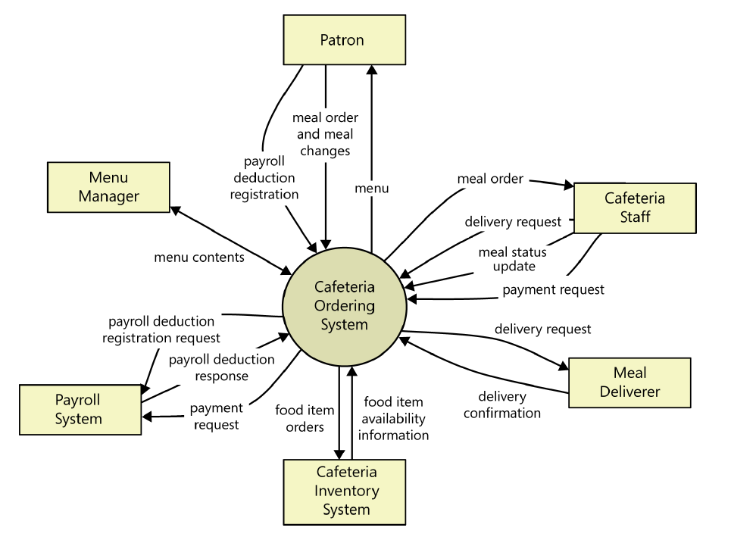

Figure A-5: Context diagram of the Cafeteria Ordering System.

**Example: User Classes and Characteristics**

Table A-1 Shows user classes and character

|  |  |
| --- | --- |
| **User class** | **Description** |
| **Patron** | A Patron is a Process Impact employee who wants to order meals to be delivered from the company cafeteria. There are about 600 potential Patrons, of which 300 are expected to use the COS an average of 5 times per week each. Patrons will sometimes order multiple meals for group events or guests. An estimated 60 percent of orders will be placed using the corporate intranet, with 40 percent of orders being placed from home or by smartphone or tablet apps. |
| **Cafeteria Staff** | The Process Impact cafeteria employs about 20 Cafeteria Staff who will receive orders from the COS, prepare meals, package them for delivery, and request delivery. Most of the Cafeteria Staff will need training in the use of the hardware and software for the COS. |
| **Menu Manager** | The Menu Manager is a cafeteria employee who establishes and maintains daily menus of the food items available from the cafeteria. Some menu items may not be available for delivery. The Menu Manager will also define the cafeteria’s daily specials. The Menu Manager will need to edit existing menus periodically. |
| **Meal Deliverer** | As the Cafeteria Staff prepare orders for delivery, they will issue delivery requests to a Meal Deliverer’s smartphone. The Meal Deliverer will pick up the food and deliver it to the Patron. A Meal Deliverer's other interactions with the COS will be to confirm that a meal was (or was not) delivered. |

**Example: Use case Diagram**

Following use case diagram is of an appointment system in which all the use case diagram relationships are presented. In further in **Table A-2** to the detail of use case diagram syntax is provided.

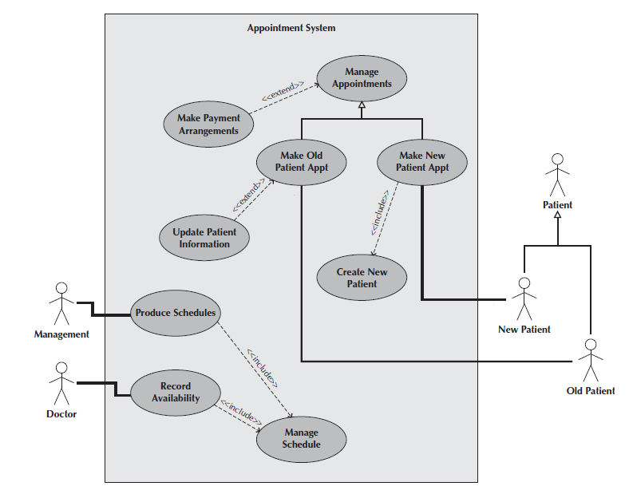

Figure A-6: Use Case Diagram of an Appointment System

**Syntax for Use case Diagram**

Table A-2 Syntax for Use case Diagram

|  |  |
| --- | --- |
| **An actor:**  ■ Is a person or system that derives benefit from and is external to the subject.  ■ Is depicted as either a stick figure (default) or, if a nonhuman actor is involved, a  rectangle with <<actor>> in it (alternative).  ■ Is labeled with its role.  ■ Can be associated with other actors using a specialization/superclass association,  denoted by an arrow with a hollow arrowhead.  ■ Is placed outside the subject boundary. |  |
| **A use case:**  ■ Represents a major piece of system functionality.  ■ Can extend another use case.  ■ Can include another use case.  ■ Is placed inside the system boundary.  ■ Is labeled with a descriptive verb–noun phrase. |  |
| **subject boundary:**  ■ Includes the name of the subject inside or on top.  ■ Represents the scope of the subject, e.g., a system or an individual  business process. |  |
| **An association relationship:**  ■ Links an actor with the use case(s) with which it interacts. |  |
| **An include relationship:**  ■ Represents the inclusion of the functionality of one use case within another.  ■ Has an arrow drawn from the base use case to the used use case. |  |
| **An extend relationship:**  ■ Represents the extension of the use case to include optional behavior.  ■ Has an arrow drawn from the extension use case to the base use case. |  |
| **A generalization relationship:**  ■ Represents a specialized use case to a more generalized one.  ■ Has an arrow drawn from the specialized use case to the base use case. |  |

**Detail Use Case Example**

The **Table A-3** below indicates a comprehensive use case template filled in with an example drawn from the Cafeteria ordering system (COS).

Table A-3 Show the detail use case template and example

|  |  |
| --- | --- |
| **Use Case ID:** | Enter a unique numeric identifier for the Use Case. e.g. UC-1 |
| **Use Case Name:** | Enter a short name for the Use Case using an active verb phrase. e.g.  Order a Meal |
| **Actors:** | [An actor is a person or other entity external to the software system being specified who interacts with the system and performs use cases to accomplish tasks.] e.g.   |  |  |  |  | | --- | --- | --- | --- | | Primary Actor: | Patron | Secondary Actors: | Cafeteria Inventory System | |
| **Description:** | [Provide a brief description of the reason for and outcome of this use case.] e.g.  A Patron accesses the Cafeteria Ordering System from either the corporate intranet or external Internet, views the menu for a specific date, selects food items, and places an order for a meal to be picked up in the cafeteria or delivered to a specified location within a specified 15-minute time window. |
| **Trigger:** | [Identify the event that initiates the use case.]e.g.  A Patron indicates that he wants to order a meal. |
| **Preconditions:** | [List any activities that must take place, or any conditions that must be true, before the use case can be started.  PRE-1. Patron is logged into COS.  PRE-2. Patron is registered for meal payments by payroll deduction. |
| **Postconditions:** | [Describe the state of the system at the conclusion of the use case execution.  POST-1. Meal order is stored in COS with a status of “Accepted.”  POST-2. Inventory of available food items is updated to reflect items in this order.  POST-3. Remaining delivery capacity for the requested time window is updated. |
| **Normal Flow:** | [Provide a detailed description of the user actions and system responses that will take place during execution of the use case under normal, expected conditions.  1.0 Order a Single Meal  1. Patron asks to view menu for a specific date. (see 1.0. E1, 1.0.E2)  2. COS displays menu of available food items and the daily special.  3. Patron selects one or more food items from menu. (see 1.1)  4. Patron indicates that meal order is complete. (see 1.2)  5. COS displays ordered menu items, individual prices, and total price, including taxes and delivery charge.  6. Patron either confirms meal order (continue normal flow) or requests to modify meal order (return to step 2).  7. COS displays available delivery times for the delivery date.  8. Patron selects a delivery time and specifies the delivery location.  9. Patron specifies payment method.  10. COS confirms acceptance of the order.  11. COS sends Patron an email message confirming order details, price, and delivery instructions.  12. COS stores order, sends food item information to Cafeteria Inventory System, and updates available delivery times. |
| **Alternative Flows:** | [Document legitimate branches from the main flow to handle special conditions (also known as extensions). For each alternative flow reference the branching step number of the normal flow and the condition which must be true for this extension to be executed. e.g.  1.1 Order multiple identical meals  1. Patron requests a specified number of identical meals. (see 1.1. E1)  2. Return to step 4 of normal flow.  1.2 Order multiple meals  1. Patron asks to order another meal.  2. Return to step 1 of normal flow.  Note: Insert a new row for each distinctive alternative flow. ] |
| **Exceptions:** | 1.0. E1 Requested date is today and current time is after today’s order cutoff time  1. COS informs Patron that it’s too late to place an order for today.  2a. If Patron cancels the meal ordering process, then COS terminates use case.  2b. Else if Patron requests another date, then COS restarts use case.  1.0. E2 No delivery times left  1. COS informs Patron that no delivery times are available for the meal date.  2a. If Patron cancels the meal ordering process, then COS terminates use case.  2b. Else if Patron requests to pick the order up at the cafeteria, then continue with normal flow, but skip steps 7 and 8.  1.1. E1 Insufficient inventory to fulfill multiple meal order  1. COS informs Patron of the maximum number of identical meals he can order, based on current available inventory.  2a. If Patron modifies number of meals ordered, then return to step 4 of normal flow.  2b. Else if Patron cancels the meal ordering process, then COS terminates use case. |
| **Business Rules** | Use cases and business rules are intertwined. Some business rules constrain which roles can perform all or parts of a use case. Perhaps only users who have certain privilege levels can perform specific alternative flows. That is, the rule might impose preconditions that the system must test before letting the user proceed. Business rules can influence specific steps in the normal flow by defining valid input values or dictating how computations are to be performed e.g.  BR-1 Delivery time windows are 15 minutes, beginning on each quarter hour.  BR-2 Deliveries must be completed between 11:00 A.M. and 2:00 P.M. local time, inclusive.  Note: If you are maintaining the business rule in a separate table in SRS then only mention here their IDs. |
| **Assumptions:** | [List any assumptions.   1. e.g. Assume that 15 percent of Patrons will order the daily special (Source: previous 6 months of cafeteria data). |

Event-Response Tables

In order to develop Event Response table first it is required to identify all possible events. Following is an example of events list and event-response table of highway intersection system.

The highway intersection system described earlier has to deal with various events, including these:

* A sensor detects a car approaching in one of the through lanes.
* A sensor detects a car approaching in a left-turn lane.
* A pedestrian presses a button to request to cross a street.
* One of many timers counts down to zero.

**Table A-4** presents a fragment of what an event-response table might look like for such a system. Each expected system behavior consists of a combination of event, system state, and response.

**Note:** You may add more information to event-response table in order to perform detail requirement analysis which includes:

* The event frequency (how many times the event takes place in a given time period, or a limit to how many times it can occur).
* Data elements that are needed to process the event.
* The state of the system after the event responses is executed.

Table A-4 Partial Event-Response Table for a Highway Intersection

|  |  |  |
| --- | --- | --- |
| **Event** | **System State** | **Response** |
| Road sensor detects  vehicle entering left-turn  lane. | Left-turn signal is red. Cross-traffic signal is green. | Start green-to-amber  countdown timer for cross-traffic  signal. |
| Green-to-amber  countdown timer reaches  zero. | Cross-traffic signal is green. | 1. Turn cross-traffic signal amber.  2. Start amber-to-red countdown timer. |
| Amber-to-red  countdown timer reaches  zero. | Cross-traffic signal is amber. | 1. Turn cross-traffic signal red.  2. Wait 1 second.  3. Turn left-turn signal green.  4. Start left-turn-signal countdown timer. |
| Pedestrian presses a  specific walk-request  button. | Pedestrian sign is solid Don’t Walk.  Walk-request countdown timer is not activated. | Start walk-request countdown timer. |
| Pedestrian presses  walk-request button. | Pedestrian sign is solid Don’t Walk.  Walk-request countdown timer is activated. | Do nothing. |
| Walk-request  countdown timer reaches  zero plus the amber  display time. | Traffic signal in walk  direction is green. | Change all green traffic signals to amber. |
| Walk-request  countdown timer reaches  zero. | Traffic signal in walk  direction is amber. | 1. Change all amber traffic signals to red.  2. Wait 1 second.  3. Set pedestrian sign to Walk.  4. Start don’t-walk countdown timer. |

Story Boarding

Following is an example of story boarding which is use to identify and analyze graphically intensive applications.







**Appendix B**

**Box-and-line diagram**

Box-and-line diagrams are often used to describe the business concepts and processes during the analysis phase of the software development lifecycle. These diagrams come with descriptions of components and connectors, as well as other descriptions that provide common inherent interpretations.

**Example:**



Figure B-7 Box-and-Line Diagram for an Online Shopping Business

Lines in the box-and-line diagrams indicate the relationship among components

* The semantic of lines may refer dependency, control flow, data flow, etc
* Lines may be associated with arrows to indicate the process direction and sequence.
* A box-and-line diagram can be used as a business concept diagram describing its application domain and process concepts

**Example of Architecture Pattern:**

The **figure B-2** shows an example of the logical package organization of the layered architecture. The top level deals with user interface, the next level is for utilities, and the one below utility provides core services. Each layer gets support from its lower adjacent layer by an interface implementation and from the related classes in the same layer.

A simple software system may consist of two layers: an interaction layer and a processing layer:

* The interaction layer provides user interfaces to clients, takes requests, validates and forwards requests to the processing layer for processing, and responds to clients.
* The processing layer receives the forwarded requests and performs the business logic process, accesses the database, returns the results to its upper layer, and lets the upper layer respond to clients since the upper layer has the GUI interface responsibility.

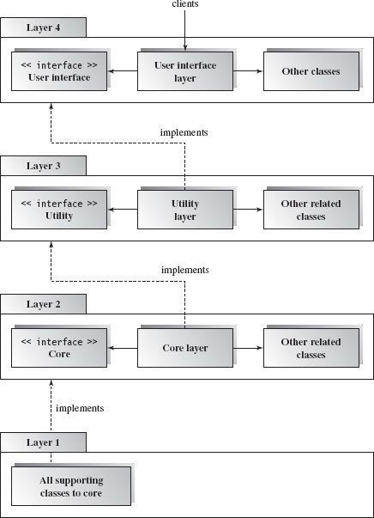

Figure B-8 Component-based Layered Architecture

**Note:** The Architecture pattern shall be selected according to the targeted system’s requirements and quality attributes. Above example is provided to demonstrate that how the system architecture is required to be presented.

**Appendix C**

**Design Models**

**Activity Diagram**

Following activity diagram is of an appointment system presenting **make an appointment** process in which all diagram’s elements are presented. In further in **Table C-1** to the detail of activity diagram syntax is provided.

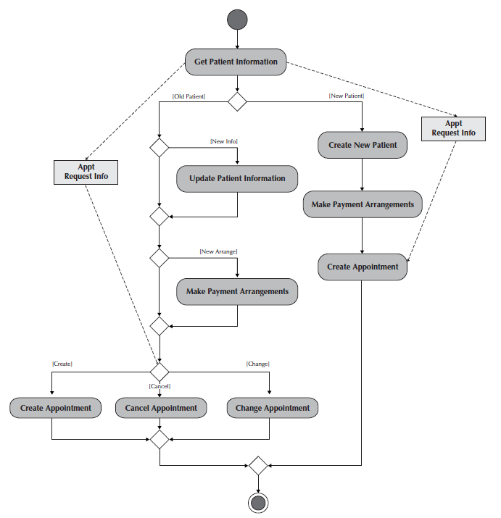**Example**

Figure C-1 Activity Diagram for Make an Appointment Process

**Activity Diagram Syntax**

Table C-1 Activity Diagram Syntax

|  |  |
| --- | --- |
| **Term and definition** | **Symbol** |
| **An action:**   * Is a simple, non-decomposable piece of behavior. * Is labeled by its name. |  |
| **An activity:**   * Is used to represent a set of actions. * Is labeled by its name. |  |
| **An object node:**   * Is used to represent an object that is connected to a set of object flows. * Is labeled by its class name. |  |
| **A control flow:**   * Shows the sequence of execution. |  |
| **An object flow:**   * Shows the flow of an object from one activity (or action) to another activity (or action). |  |
| An initial node:   * Portrays the beginning of a set of actions or activities. |  |
| **A final-activity node:**   * Is used to stop all control flows and object flows in an activity (or action). |  |
| **A final-flow node:**   * Is used to stop a specific control flow or object flow. |  |
| **A decision node:**   * Is used to represent a test condition to ensure that the control flow or object flow only goes down one path. * Is labeled with the decision criteria to continue down the specific path. |  |
| **A merge node:**   * Is used to bring back together different decision paths that were created using a decision node. |  |
| **A fork node:**   * Is used to split behavior into a set of parallel or concurrent flows of activities (or action) |  |
| **A join node:**   * Is used to bring back together a set of parallel or concurrent flows of activities (or action) |  |
| **A swimlane:**   * Is used to break up an activity diagram into rows and columns to assign the individual activities (or actions) to the individuals or objects that are responsible for executing the activity (or action) * Is labeled with the name of the individual or object responsible |  |

**Class Diagram**

Following class diagram is of an appointment system in which all class diagrams elements are presented. In further in **Table C-2** to the detail of class diagram syntax is provided.

**Example**

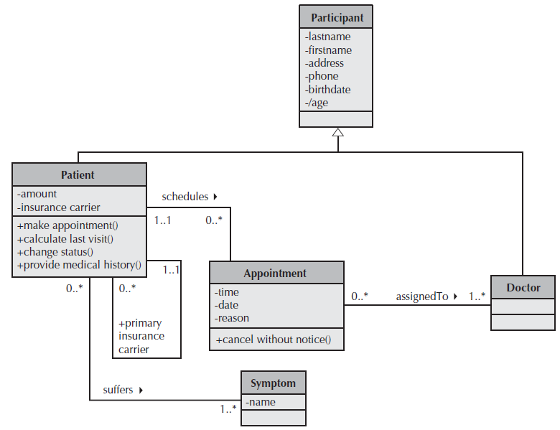

Figure C-2 Class Diagram for an Appointment System

**Class Diagram Syntax**

Table C- 2 Class Diagram Syntax

|  |  |
| --- | --- |
| **Term and definition** | **Symbol** |
| **A class:**   * Has a name typed in bold and centered in its top compartment. * Has a list of attributes in its middle compartment. * Represents a kind of person, place, or thing about which the system will need to capture and store information. * Has a list of operations in its bottom compartment. * Does not explicitly show operations that are available to all classes. |  |
| **An attribute:**   * Represents properties that describe the state of an object. * Can be derived from other attributes, shown by placing a slash before the attribute’s name. | attribute name  /derived attribute name |
| **An operation:**   * Represents the actions or functions that a class can perform. * Can be classified as a constructor, query, or update operation. * Includes parentheses that may contain parameters or information needed to perform the operation. | operation name () |
| **An association:**   * Represents a relationship between multiple classes or a class and itself. * Is labeled using a verb phrase or a role name, whichever better represents the relationship. * Can exist between one or more classes. * Contains multiplicity symbols, which represent the minimum and maximum times a class instance can be associated with the related class instance. |  |
| **A generalization:**   * Represents a-kind-of relationship between multiple classes. |  |
| **An aggregation:**   * Represents a logical a-part-of relationship between multiple classes or a class and itself. * Is a special form of an association. |  |
| **A composition:**   * Represents a physical a-part-of relationship between multiple classes or a class and itself * Is a special form of an association. |  |

**Sequence Diagram**

Following example shows an instance sequence diagram that depicts the objects and messages for the Make Old Patient Appt use case, which describes the process by which an existing patient creates a new appointment or cancels or reschedules an appointment. In further in **Table C-3** to the detail of class diagram syntax is provided.

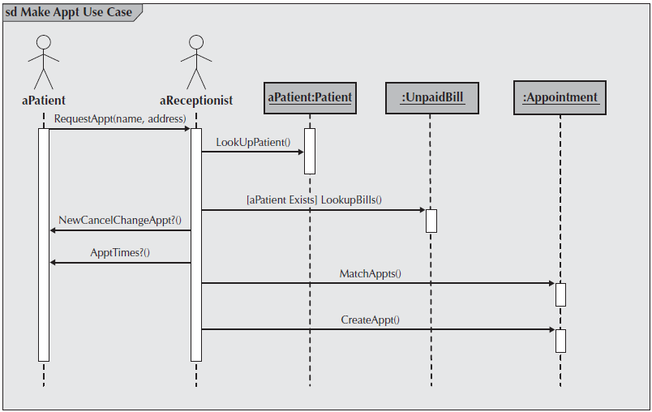**Example**

Figure C-3 Example Sequence Diagram

**Sequence diagram Syntax**

Table C-3 Sequence Diagram Syntax

|  |  |
| --- | --- |
| **Term and definition** | **Symbol** |
| **An actor:**   * Is a person or system that derives benefit from and is external to the system. * Participates in a sequence by sending and/or receiving messages. * Is placed across the top of the diagram. * Is depicted either as a stick figure (default) or, if a nonhuman actor is involved, as a rectangle with <<actor>> in it (alternative). |  |
| **An object:**   * Participates in a sequence by sending and/or receiving messages. * Is placed across the top of the diagram. |  |
| **A lifeline:**   * Denotes the life of an object during a sequence. * Contains an X at the point at which the class no longer interacts. |  |
| **An execution occurrence:**   * Is a long narrow rectangle placed atop a lifeline. * Denotes when an object is sending or receiving messages. |  |
| **A message:**   * Conveys information from one object to another one. * An operation call is labeled with the message being sent and a solid arrow, whereas a return is labeled with the value being returned and shown as a dashed arrow. |  |
| **A guard condition:**   * Represents a test that must be met for the message to be sent. |  |
| **For object destruction:**   * An X is placed at the end of an object’s lifeline to show that it is going out of existence. |  |
| **A frame:**   * Indicates the context of the sequence diagram. |  |

**Behavioral State Machine Diagram**

Following example of a behavioral state machine representing the patient class in the context of a hospital environment. From this diagram, we can tell that a patient enters a hospital and is admitted after checking in. If a doctor finds the patient to be healthy, he or she is released and is no longer considered a patient after two weeks elapse. If a patient is found to be unhealthy, he or she remains under observation until the diagnosis changes.

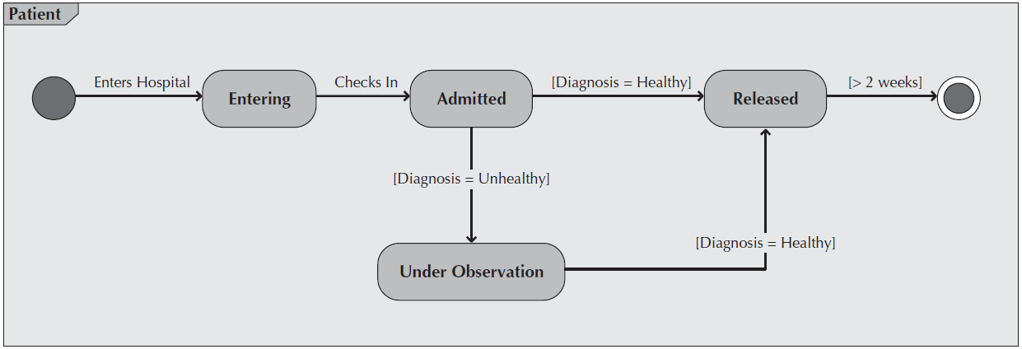**Example**

Figure C-4 Sample Behavioral State Machine Diagram

**Behavioral State Machine Diagram Syntax**

Table C-4 Behavioral State Machine Diagram Syntax

|  |  |
| --- | --- |
| **Term and definition** | **Symbol** |
| **A state:**   * Is shown as a rectangle with rounded corners. * Has a name that represents the state of an object. |  |
| **An initial state:**   * Is shown as a small, filled-in circle. * Represents the point at which an object begins to exist. |  |
| **A final state:**   * Is shown as a circle surrounding a small, filled-in circle (bull's-eye). * Represents the completion of activity. |  |
| **An event:**   * Is a noteworthy occurrence that triggers a change in state. * Can be a designated condition becoming true, the receipt of an explicit signal from one object to another, or the passage of a designated period of time. * Is used to label a transition. |  |
| **A transition:**   * Indicates that an object in the first state will enter the second state. * Is triggered by the occurrence of the event labeling the transition. * Is shown as a solid arrow from one state to another, labeled by the event name. |  |
| **A frame:**   * Indicates the context of the behavioral state machine. |  |

**Data Flow Diagram**

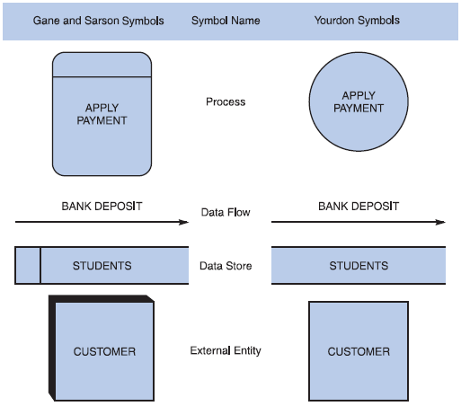**Data flow diagram symbols, symbol names, and examples**

Figure C-5 Data flow diagram symbols, symbol names, and examples of the Gane and Sarson and Yourdon symbol sets.

**Guidelines for Drawing DFDs**

**Step 1: Draw a Context Diagram**: The first step in constructing a set of DFDs is to draw a context diagram. A **context diagram** is a top-level view of an information system that shows the system’s boundaries and scope. Data stores are not shown in the context diagram because they are contained within the system and remain hidden until more detailed diagrams are created.

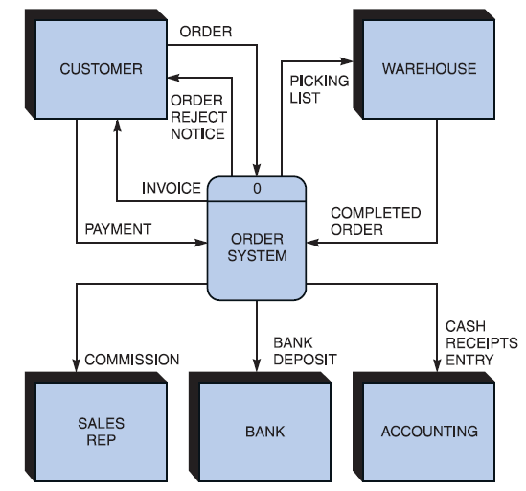**Example**

Figure C-6 Context diagram DFD for an order system.

**Step 2: Draw a Diagram 0 DFD:** To show the detail inside the black box, you create DFD diagram 0. **Diagram 0** zooms in on the system and shows major internal processes, data flows, and data stores. Diagram 0 also repeats the entities and data flows that appear in the context diagram. When you expand the context diagram into DFD diagram 0, you must retain all the connections that flow into and out of process 0.

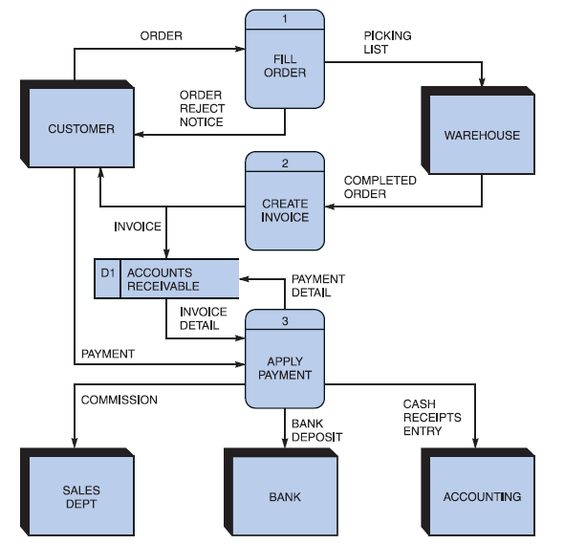**Example**

Figure C-7 Diagram 0 DFD for the order system.

**Step 3: Draw the Lower-Level Diagrams:**

To create lower-level diagrams, you must use leveling and balancing techniques. **Leveling** is the process of drawing a series of increasingly detailed diagrams, until all functional primitives are identified.

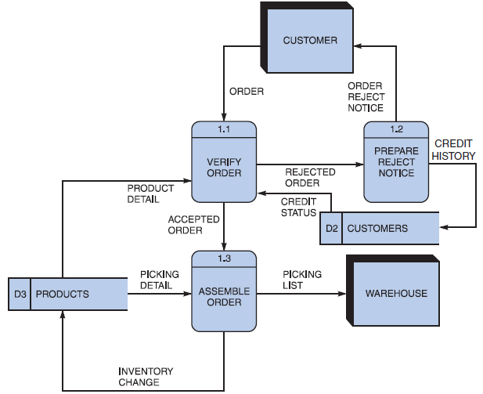**Leveling Example**

Figure C-8 Diagram 1 DFD shows details of the FILL ORDER process in the order system.

**Balancing** maintains consistency among a set of DFDs by ensuring that input and output data flows align properly.

**Balancing Example**

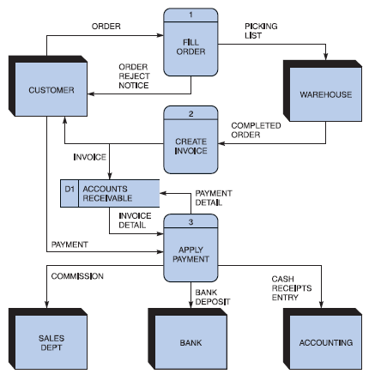Order System Diagram 0 DFD

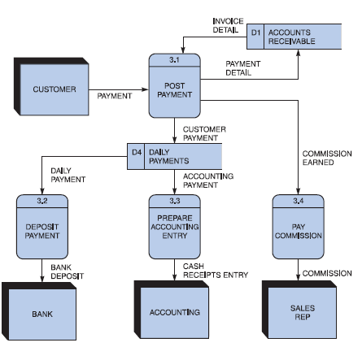Order System Diagram 3 DFD

The order system diagram 0 is shown at the top of the figure and exploded diagram 3 DFD (for the APPLY PAYMENT process) is shown at the bottom. The two DFDs are balanced, because child diagram at the bottom has the same input and output flows as the parent process 3 shown at the top.

**Appendix D: General Coding Standards & Guidelines**

1. Follow a consistent variable naming convention throughout the code. E.g.
   * Snakecase (words are delimited by “_” like: variable_one)
   * Pascalcase (words are delimited by capital letters like: VariableOne)
   * Camelcase (words are delimited by capital letters except the initial word like: variableOne)
   * Hungarian Notation (describes the variable type or purpose at the start of the variable name like: arrDistributeGroup)
2. Use naming that visually describes scope like privateField, Const etc
3. Use read only/immutable when a field’s value should not be changed after initialization
4. Use only get, for properties that should not be updated from outside
5. Name functions according to their functionalities.
6. Insert appropriate comments to make the code understandable to any reader. Additionally follow a consistent style to do so. E.g.

/* the below function will be used for the addition of two variables*/

int Add(){

//logic of the function

}

Avoid commenting on obvious things

1. Make use of indentation for indicating the start and end of the control structures along with a clear specification of where the code is between them.
2. Follow consistent naming convention for files and folders.
3. Follow proper structure for classes
4. Group code entities logically into projects/packages/modules/folders
   1. Separate logical layers of application into different modules/services/utilities etc.
   2. User separate files for each class, struct, interface, enum etc. Name of the file and the enclosing entity must be same. E.g., class Employee in Employee.cs/Employee.java
5. Define and use everything within the minimum scope possible
6. Use proper access modifier for all code entities if required
7. Code entities should have maximum cohesion and least coupling possible.
8. Follow DRY law.
   1. Do not repeat code.
   2. A piece of knowledge should exist only in one place within the codebase/application
   3. Reuse code as much as possible
   4. Always write short methods
   5. Single method should not have too many logic, long conditional flow or too many parameters
9. Strictly follow Single Responsibility Principle (SRP) when writing methods, classes, modules, projects, packages, or any other code entities.
10. Write classes and other code entities that are easy to extend without modification.
11. Handle exceptions
12. Log exception and other significant event details
13. Follow a consistent convention for logging all over the application

**Appendix E**

**Business rules testing**

Methodology for creating decision table:

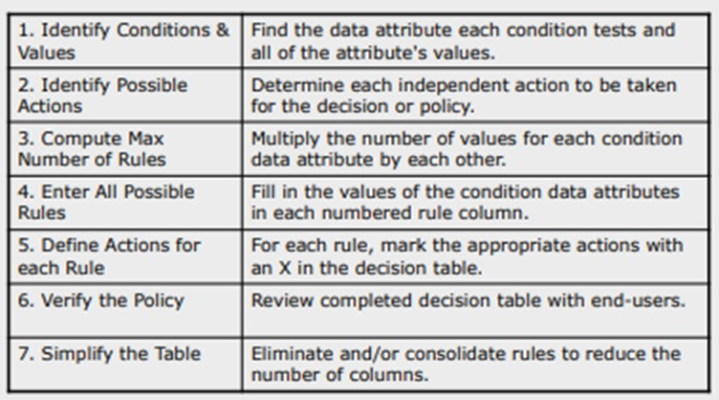

**Example:**

The provided example is of a super store.

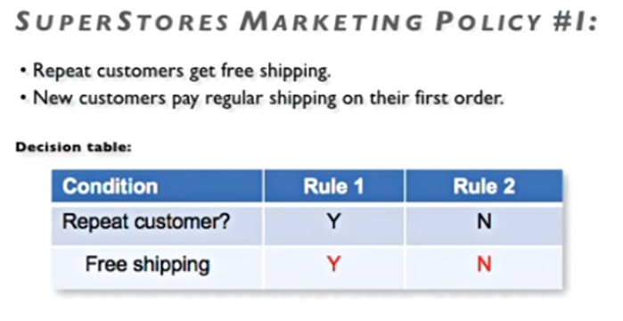

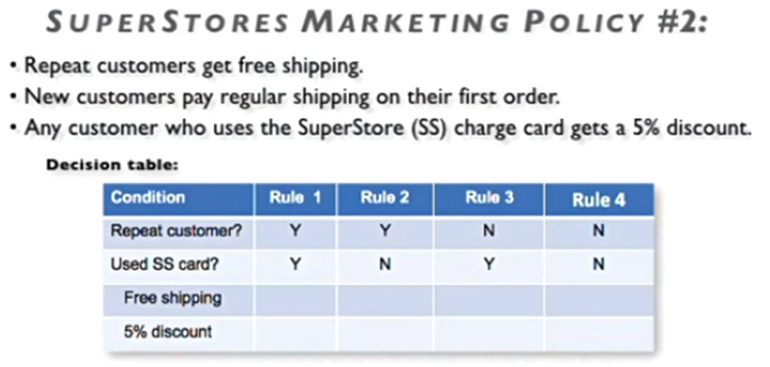

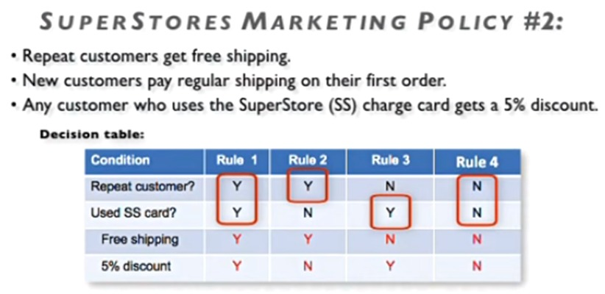

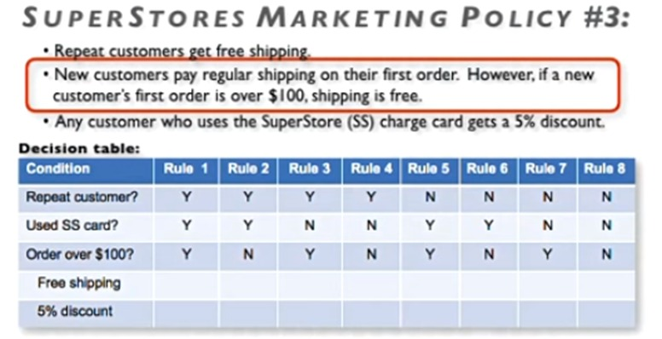

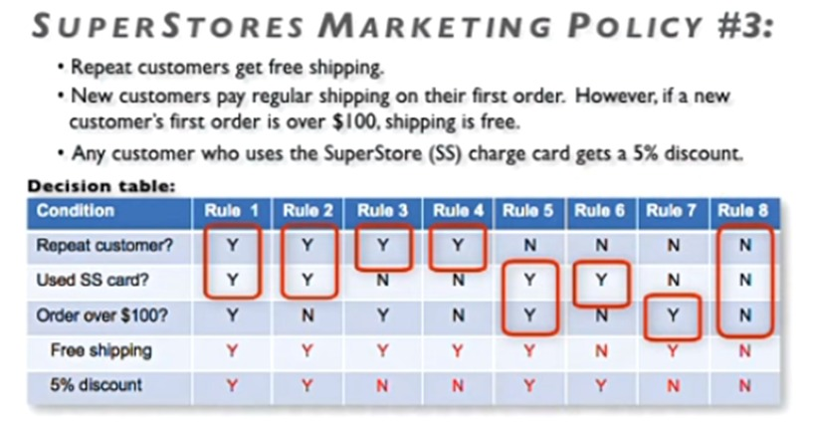

* Now Combine rules where it is apparent that an alternative does not make a difference in the outcome

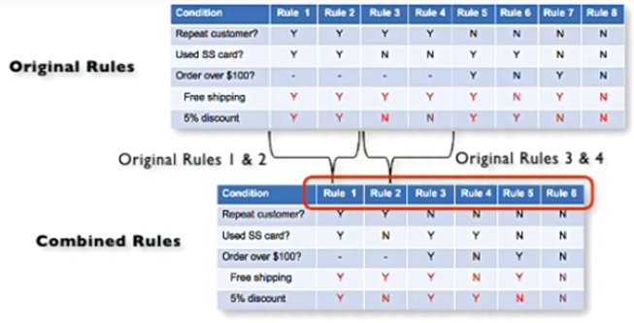

This is the final table and now you have to create test cases on every rule. In above example there are 6 rules so there shall be 6 test cases.